
NCICB

C3D Connector 1.5 Software Architecture Guide

Version No: 1.0
Last Modified: 05/05/2008

Author: Patrick Conrad
Amit Srivastava
Team: C3D
Client: National Cancer Institute - Center for Bioinformatics,
National Institutes of Health,
US Department of Health and Human Services

Document History

Document Location
The most current version of this document is located on the C3D Tools GForge Site:
none yet

Revision History
Version Number | Revision Date | Author | Summary of Changes
1.0 | 05/05/2008 | Patrick Conrad | Initial Draft

Review
Name | Team/Role | Version | Date Reviewed | Reviewer Comments

Related Documents
More information can be found in the following related documents:

Document Name

Table of Contents
Document History 2
Document Location 2
Revision History 2
Review 2
Related Documents 2
Table of Contents 3
Table of Figures 4
1. Introduction 5
1.1. Purpose of this Document 5
1.2. Methodologies, Tools and Techniques 5
1.3. Key Stakeholders 5
1.4. Points of Contact 5
2. Technical Overview/ 6
2.1. Background Information 6
2.1.1. BRIDG 1.1.1 6
2.1.2. EnrollPatient 6
2.1.3. GetCDEs 6
2.1.4. GetCDEData 6
2.1.5. CCTS Efforts 6
2.1.6. Risks 7
2.1.6.1. Code Complexity 7
2.1.6.2. Testing 7
2.1.7. Assumptions 7
2.1.8. Dependencies 7
3. System Architecture 8
3.1. Architectural Goals 8
3.2. Architectural Tiers 8
3.3. Design 8
3.4. Class Diagram 10
4. Deployment 11

Table of Figures

No table of figures entries found.

- Introduction
The CDMS Connector provides grid services as an interface to operations that support the clinical trials workspace. In this release of the CDMS Connector, effort is focusing on the implementation of services to the C3D workspace.

To briefly summarize, the main goals of the 1.5 release are focusing on services of a C3D implementation:

- Enhance the C3D patient enrollment service to allow additional data to be passed into C3D, in a configurable manner.

- Re-factoring of code base to adopt the BRIDG 1.1.1 data model.

- Introduce basic data retrieval from the C3D database using CDE identifiers of caDSR.

- Introduce retrieval of CDE identifiers at the study level from the C3D database.

- Introduce security levels to safeguard the movement of data in and out of the C3D service adapters.

Purpose of this Document
The main purpose of this document is to provide a high level design and architectural description of the new capabilities in the 1.5 release of the C3D Connector.

Methodologies, Tools and Techniques
Part of the development tasks are being done in Java primarily using Eclipse as the Integrated Development Environment (IDE). Ant is used for daily building of the code, unit testing, and Javadoc generation. The project artifacts are being tracked in GForge.
More development work is being done in the C/C++ realm primarily using Visual C++ as the Integrated Development Environment. The method is used due to the underlying API structure used by Oracle Clinical. The project artifacts for this development effort are also being tracked in GForge.
Finally, as C3D is Oracle based, query development tasks are being done with SQL and PL/SQL, using the Oracle 9i PL/SQL engine. T.O.A.D. and SQL/Plus are also being used in the development and testing phases of the database query code. Artifacts from this effort are also being tracked in GForge.

Key Stakeholders
Name | Description | Responsibilities
Christo Andoyadis | C3D Product Manager | Directs C3D Projects
Charles Griffin | C3D Project Manager | Project Management
Patrick Conrad | C3D Project Lead | Project Lead

Points of Contact
Name | Responsibilities
Christo Andoyadis | Directs C3D Projects
Charles Griffin | Project Management
Patrick Conrad | Project Lead

- Technical Overview/

Background Information
The CDMS Connector was originally designed as a proof of concept, showing that a Java based service could be created that would interact with the C3D environment. The early proof of concept bypassed the API functionality provided with C3D and worked directly with the underlying objects of the database. This iteration of the service was reworked so that the API functions would be used instead.

As the CDMS Connect is a Grid Service, it does not have a user interface of its own. It relies on other external systems to invoke it and provides its output through normal Java messaging services.

The 1.5 version of CDMS Connector will enhance one existing component while introducing three new components. The following sections will describe those components.

BRIDG 1.1.1
Along with the name change, the CDMS Connector Release 1.5 is being refactored to use the BRIDG 1.1.1 model. The previous release of the Connector used the BRIDG 1.0 model. The refactoring will affect every service of the Connector.

EnrollPatient
The EnrollPatient component is being enhanced in several ways. The primary enhancement involves allowing more data elements to be passed to C3D during the enrollment process. Along with the current data values for enroll date and patient initials, the enhancement allows for patient birth date and gender as well as patient first and last names. To provide a more robust user option with this enhancement, the service is being additionally modified such that each the data values mentioned are loaded based upon a set of configurable controls. The service will only load those data items into C3D that the user has configured to do so. The configuration of this service will be kept external to the service itself in a java parameters file.

GetCDEs
The first of the new services being introduced in Release 1.5 is GetCDEs. This service will provide to the requestor, a list of each of the CDEs (Common Data Elements) used to build the requested study. Along with the CDE value and version, the response with include the following context information related to the CDE:
- DCI, DCM and Event name
- Question Name, Prompt and CDE values.
This service can be used to identify the caDSR elements used to the data panels of C3D, and can be used in the other service provided with this release.

GetCDEData
The next new services being introduced in Release 1.5 is GetCDEData. This service will provide to the requestor all data collected within the requested study relating to the requested CDE and version. Along with the data values, the requester will also receive the following context information:
- DCI, DCM and Event name.
- DCI and DCM date.
- Patient position.
- Question Group Name.
- Question Name, Prompt and CDE Value.

CCTS Efforts
Concurrently with the ongoing development efforts of Release 1.5 are the efforts to maintain, test, deploy, document and demonstrate the C3D Connector Release 1.0 as a component of the CCTS tier. These efforts can at times interfere with the schedule of the 1.5 release. To alleviate as much dual supports a possible, completed interactions of the 1.5 release will be rolled into the most recent CCTS version. This will not only reduce the about of effort required to maintain two separate code bases, but will also provide insight to the other teams of the CCTS Effort of the services that the CDMS Connector is providing

Risks

Code Complexity
Due to the nature of the Grid being Java based, and the application interfaces of C3D being C based, introduces a complexity between the interchange of data and use of libraries between the two programming school. Also inherent in the application interfaces of C3D is the need for the pre-compilation of the C/C++ code via Oracle’s Proc*C compiler. To reduce this dependency, SQL and PL/SQL coding and queries will be limited to as few C++ programs as possible. As SQL and PL/SQL can be readily used within Java, this will be emphasized.

Testing
We are using junit tests as much as possible for all work involving data and object layers, and wherever possible we are using them on the existing code. Due to the nature of the registration process within C3D, we will be investigating the ability to “remove” registrations to create a cleanup operation. In the future, a regression test suite will help with QA, though it will not replace unit and usability testing.

Assumptions
We have to assume that the C3D API elements (DLLs) that we depend on will remain as the standard external access points to C3D, and that any changes to these underlying elements are well document and tested by the providing vendor.

Dependencies
The 1.5 release is dependent on the C3D APIs. Any changes to these elements would require a new release of the C3D adaptors. The C3D APIs themselves have a dependency on the Oracle Client version as well, which is currently the v8.0.6 release. The Oracle 8.0.6 has a dependency on its operating system, which is certified as Windows 2003 (32 Bit) Service Pack 2.
- System Architecture

Architectural Goals
The chief goals of the architecture were as follows:
- Create a caGrid gridservice interface
- Decoupled layers for handling information exchange protocols (e.g. BRIDG) and date persistence. In other words, it should be easy to use a new protocol or a new Clinicals database without much hassle.

Architectural Tiers
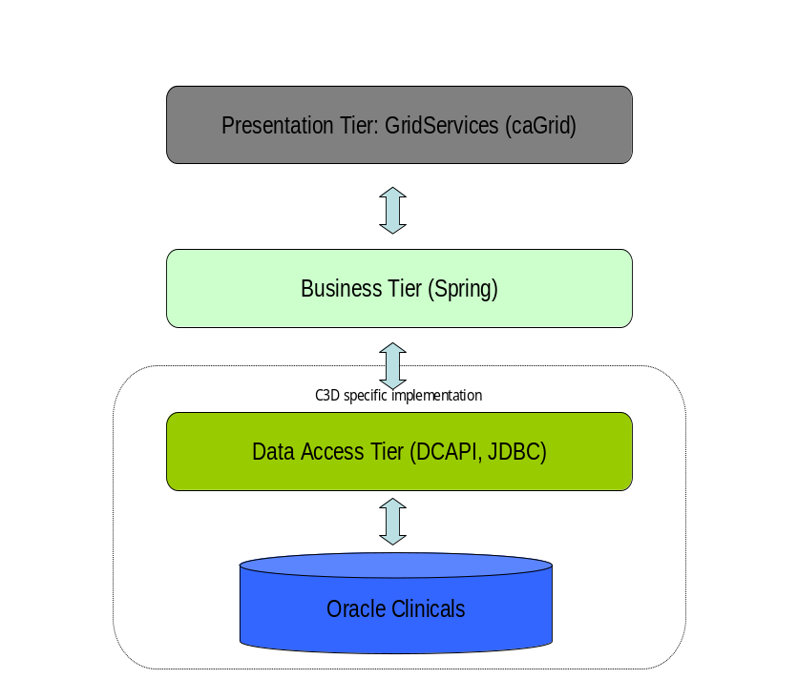
CDMS Connector utilizes caGrid1.2 and BRIDG2.0 to expose the services. Internally, it is built in tiers with communication happening between the adjacent tiers. The n-tier architecture would make the system flexible and more manageable in the long run where any tier of the system could be replaced with another identical tier.

Domain: The domain model of CDMS Connector grid-service is based on BRIDG2.0. The connector internally uses a different and smaller model with an adapter to convert between the two. The presence of the two different models provides the flexibility of altering the grid-service model without requiring any changes in the rest of the layers.

Business: The business layer contains most of the logic for conversion of the grid-service model (currently BRIDG) to the internal model and the validation of the received data. The layers have been glued together by using the dependency mechanism of Spring Framework.

Data Access: The data access layer in CDMS Connector is built using the Data Access Objects (DAO) Design Pattern. All the logic related to fetching and persisting data resides in the DAO and thus makes the architecture flexible enough to use any other database simply by replacing the DAO layer.
The current Oracle Clinical based implementation of DAO uses DCAPI and JDBC to fetch and persist the data.

Design
All the services work in the following generic manner.
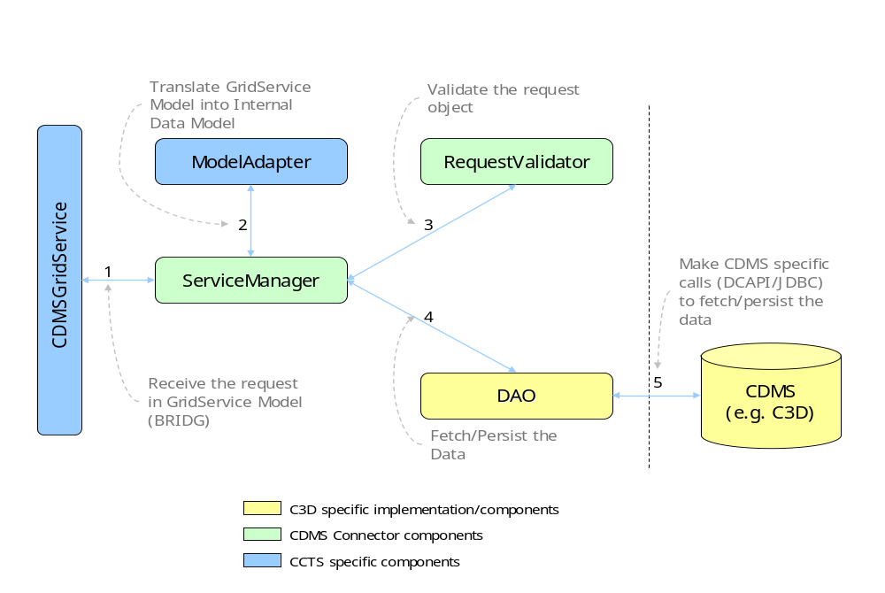
The request is received by the grid-service layer and passed on to the corresponding ServiceManager, which the makes the calls to necessary methods to accomplish the task.
- The request (EnrollPatientRequest, LoadLabsRequest or GetStudyRequest) is passed on to the corresponding ServiceManager.
- The first job inside ServiceManger is to translate the request from BRIDG Model to the internal data model. A utility method in the ModelAdapter does the task. The request object return from the ModelAdapter is used elsewhere in the processing.
- The request object is then passed on to the corresponding RequestValidator to validate the request.
- After the request is found to be completely valid, it is sent to the DAO Layer for further processing.
- The DAO then makes CDMS specific calls to store the data. In the case of C3D Java Native (JNI) calls are made to DCAPI dll’s which then interact with the database. The database URL and credentials are read from an external properties file. Also, the various data-fields to stored in the database can be easily controlled through a xml file.

Class Diagram
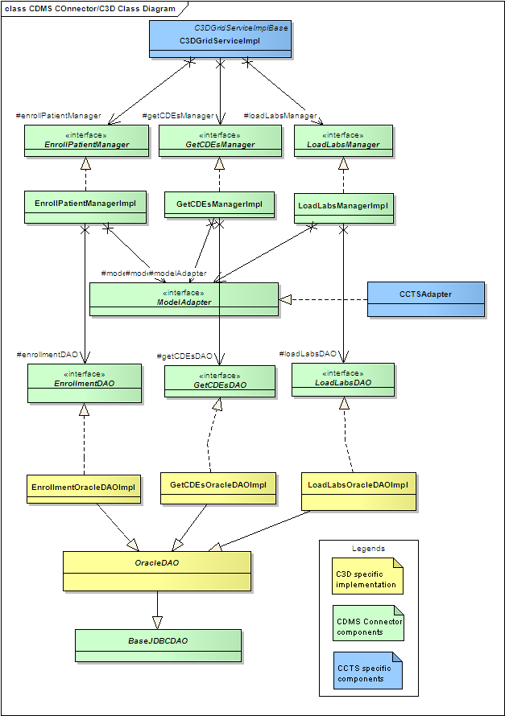
- Deployment
CDMS Connector gets deployed on Apache tomcat as a war file and connects to the Oracle database using DCAPI and JDBC calls.

